GOVT. COLLEGE FOR WOMEN :: HINDUPUR
DEPARTMENT OF BOTANY
PERSONAL PROFILE

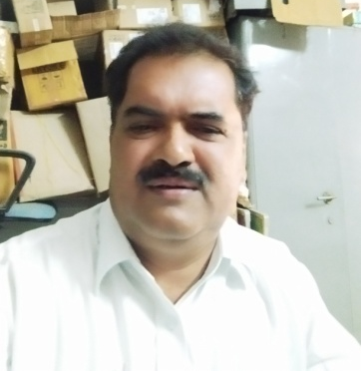
Dr. B.Aswarthappa, M. Sc., Ph. D.
Designation: Lecturer in Botany,
Govt. College for Women , Hindupur
Andhra Pradesh, India

Mobile : 9182704339

E-mail : boddiga819@gmail.com,

TEACHING EXPERIENCE
COURSES TAUGHT | NAME OF THE COLLEGE | DURATION
U. G. (B .Sc.) | Experience in other colleges | 20-11-2000 to 21-10-2021
U. G. (B .Sc.) | N.S.P.R.GOVERNMENT DEGREE COLLEGE FOR WOMEN , HINDUPUR | 22-10-2021 To Till Date

Trainning Programmes attended :

SL.NO | PROGRAMME | DATE | VENUE
1 | Five - Day Residential Training Programme for Teachers | 07-12-2022 To  11-12 -2022 | APHRDI, SRIKALAHASTI
2 | English Medium of Instruction  (6 Day Training of the Trainers Program – ToT) | 05-06-2023 to  10-06-2023 | NRC, GDC  Anantapur

RESEARCH PUBLICATIONS :
- Preliminary Phytochemical and Anti-microbial activity of CYANOTIS TUBEROSA .
- Phytochemical and Anti-microbial analysis of essential oils of FAGONIA CRETICA.
- Anti-microbial activity of shoot extract of CRYPTOLEPIS BUCHANANI.
Extension work & Best Practices:
- Celebrated Science day every year.
- Arranged Guest Lectures in the college.
- Guest Lectures given in various institutions.

